**Integrate Jenkins with Sonarqube,Git,Tomcat:**

* First we need to create the 3 ec2 instance one for Jenkins,another for tomcat and one more instance(t2.medium taken for sonar instance) for sonarqube and open the port no.9000 for sonarqube server and 8080 for Jenkins,tomcat.
* Update the servers by using **apt update -y** command and install java on 3 servers.
* Install the Jenkins and maven on Jenkins server and install tomcat on tomcat server.
* On sonarqube instance we need to create user with the name of sonarqube by using **adduser username** command and swith to the sonarqube user by using **su – username** command.
* Change the owner permission by using **chown sonarqube:sonarqube folder or file name -R** command.
* Change the file permission by using **chmod 777 filename -R** command.
* Install the sonarqube from **binaries.sonarsource.com.**

This is command

Wget <https://binaries.sonarsource.com/Distribution/sonarqube/sonarqube-9.2.0.49834.zip>

* Install the unzip on sonarqube server and unzip by using **unzip folder name** command.
* Go to **sonarqube** folder and go to **bin** folder and go to **linux-x86-64** folder .
* Start the sonar server by using **sh sonar.sh start** command and log into sonarqube server by using server i.p address with port no.9000
* Go to manage Jenkins > plugins > available plugins search for sonar scanner and install it and restart Jenkins.
* Log into Jenkins server and go to **manage Jenkins** and go to **system** which is under system configuration section.
* Configure the sonarqube server with Jenkins like sonarqube server url,add the sonarqube token(for the token we can go to sonarqube server click on **A** and click on **my account** and enter the any name click on generate token will be generated copy this token and paste it on Jenkins credentials).
* Go to tools and serach for **sonarqubescanner installation** option and click on add enter name and click on apply and save.
* Install the **deploy to container** plugin .
* Create the pipeline job and write the pipeline script or generate the script by using pipeline syntax option.

Declarative pipeline script

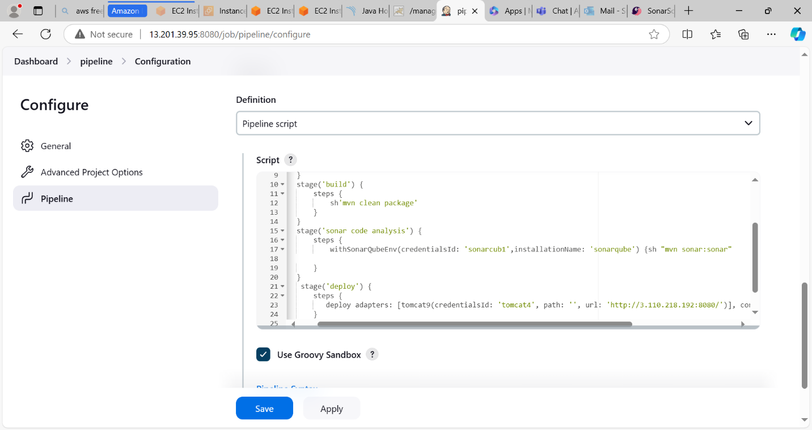

Build is success

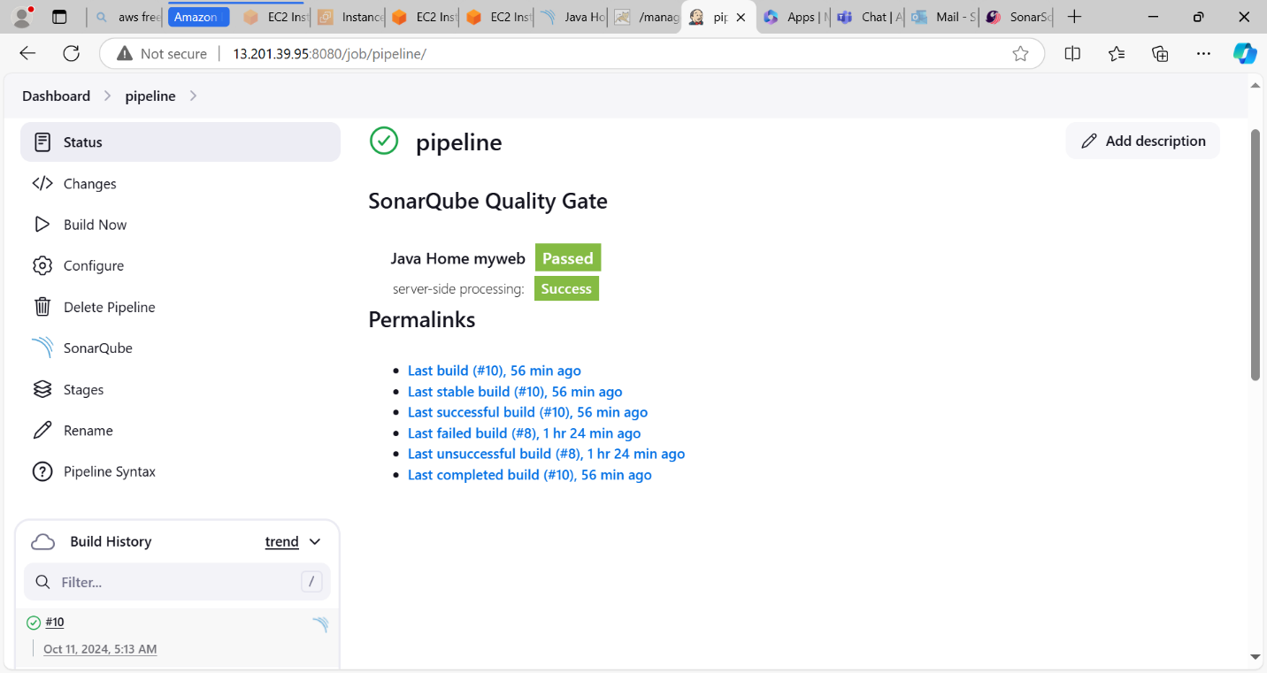

Code analysis by sonarqube

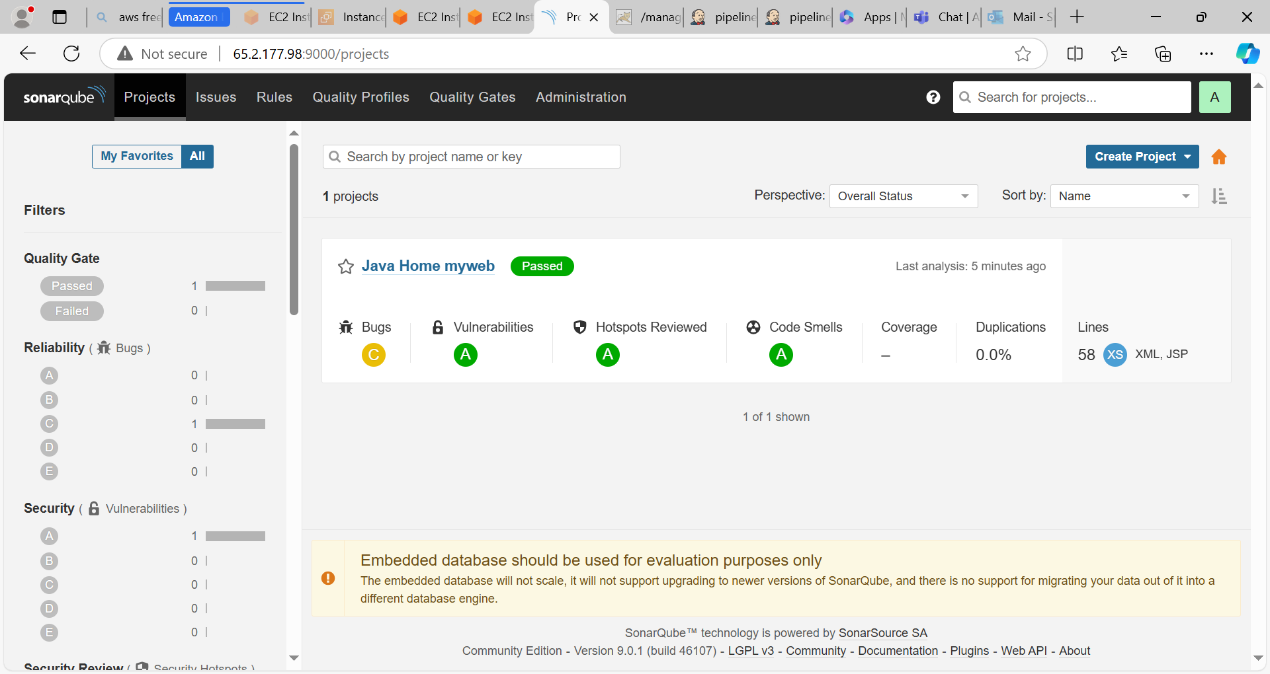

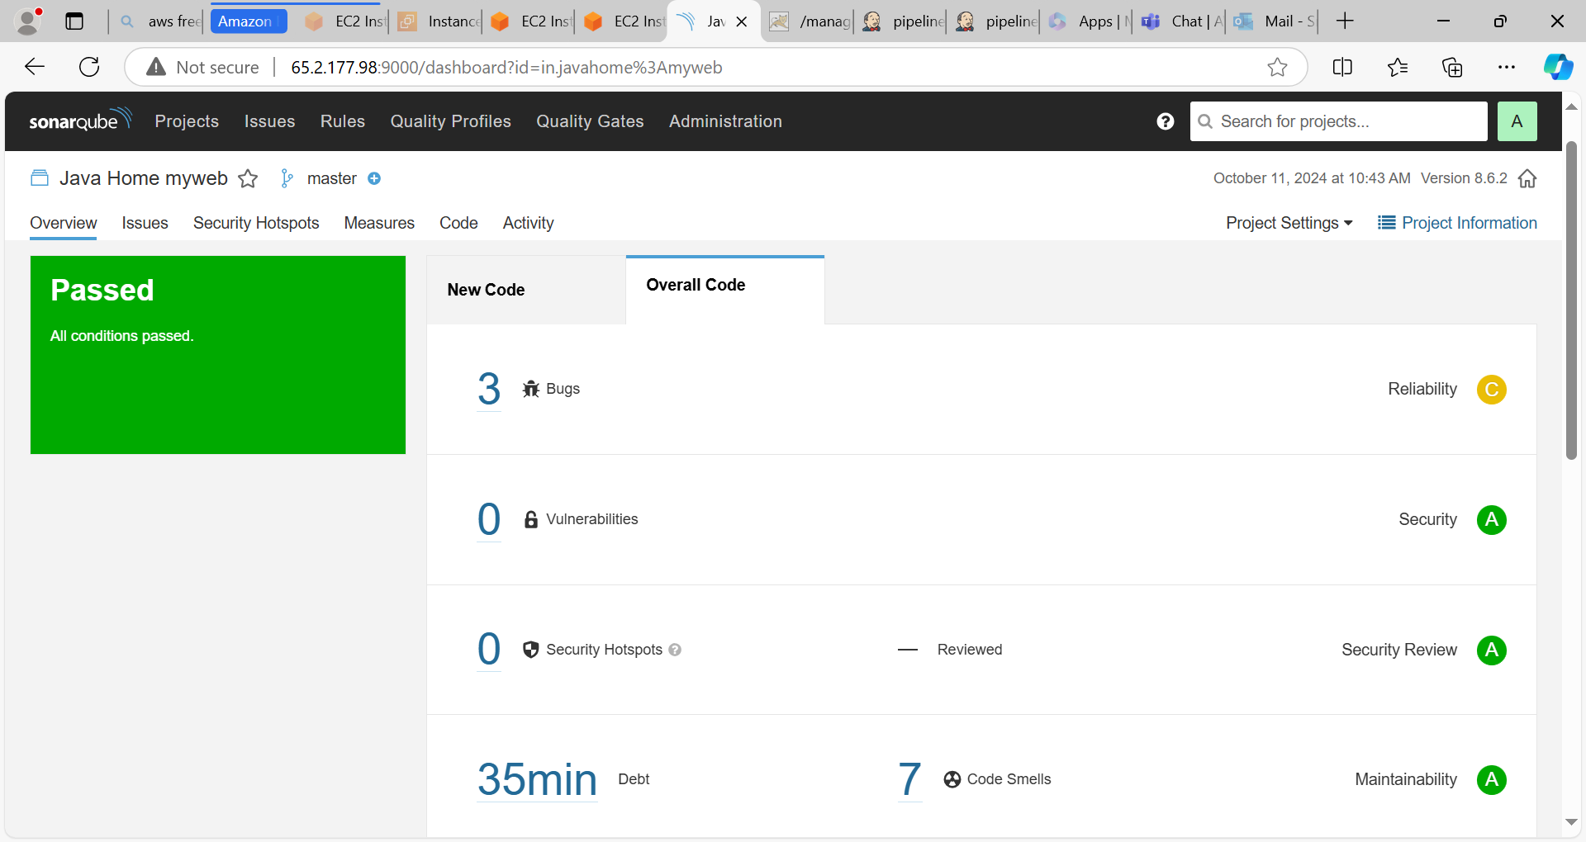

Deploy on Tomcat

